JWB-001_README.PDF

Please refer to fabrication drawing for all specifications and fabrication details.

Quantity: 50

Delivery: Standard

Shipping address:

Jewelbots

50 Eldridge St.

5th floor

New York, NY 10002

Design contacts:

Sangeet Dandona

Mobile: (909) 282-2819

Scott Davison

Mobile: (215) 316-2509

Part Number-----------------------: JWB-001

Revision--------------------------: 3.7

Board size------------------------: 0.94488" x 0.94488"

Board Thickness-------------------: 0.035"

Board type------------------------: FOUR LAYER

P.C.B material--------------------: 370HR

Finished Copper-------------------: 1 oz

Finish----------------------------: ENIG

Solder Mask on Bare Copper--------: Yes

Mask type-------------------------: LPI

Mask color------------------------: GREEN

Silk screen color-----------------: WHITE

Surface mount---------------------: Yes

Smallest trace size---------------: 0.003"

Smallest clearance between traces-: 0.003"

Layer Stackup:

|  |  |  |  |  |  |
| --- | --- | --- | --- | --- | --- |
| Layer Name | Type | Material | Thickness (mil) | Dielectric  Material | Dielectric  Constant |
| Top Overlay | Overlay |  |  |  |  |
| Top Solder | Solder Mask/Coverlay | SurfaceMaterial | 0.4 | Solder Resist | 3.5 |
| Top | Signal | Copper | 1.2 |  |  |
| Core 1 | Dielectric | Prepreg | 2.8 | FR-4 | 4.5 |
| Layer 2 | Signal | Copper | 1.2 |  |  |
| Core 2 | Dielectric | Core | 24 | FR-4 | 4.5 |
| Layer 3 | Signal | Copper | 1.2 |  |  |
| Core 3 | Dielectric | Prepreg | 2.8 | FR-4 | 4.5 |
| Bottom | Signal | Copper | 1.2 |  |  |
| Bottom Solder | Solder Mask/Coverlay | SurfaceMaterial | 0.4 | Solder Resist | 3.5 |
| Bottom Overlay | Overlay |  |  |  |  |

Request Impedance Control on the following nets:

Differntial Nets:

ANT1 (Val: 100ohms)

Coord: (138, 236) in mil

ANT2 (Val: 100ohms)

Coord: (138, 221) in mil

Zo_diff = 50ohms

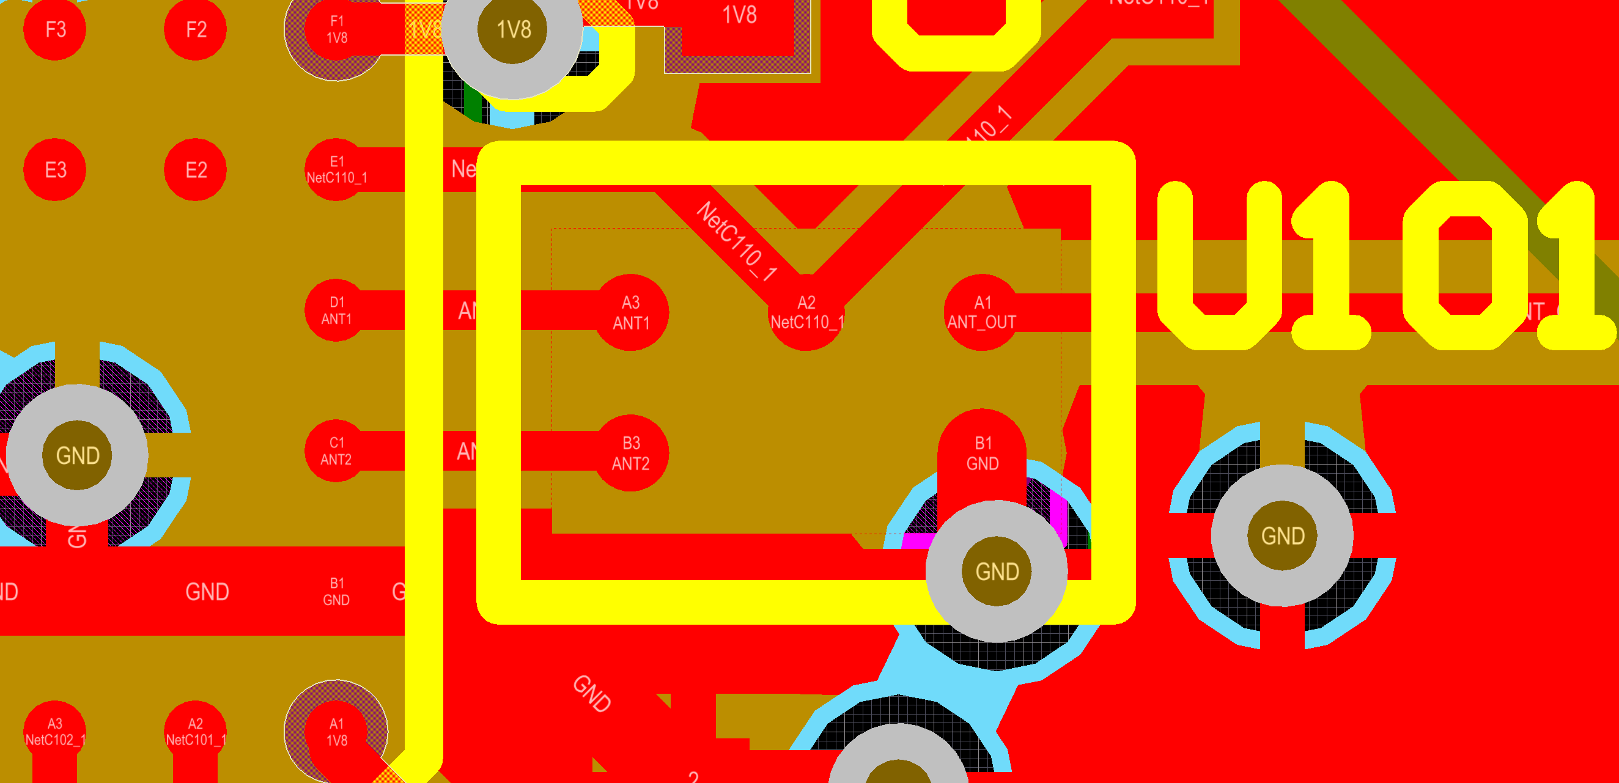

Fig. 1: Diff-pair route

Single Nets:

ANT_OUT (Val: 50ohms)

Coord: (340, 220) in mil

ANT_MATCH (Val: 50ohms)

Coord: (379, 126) in mil

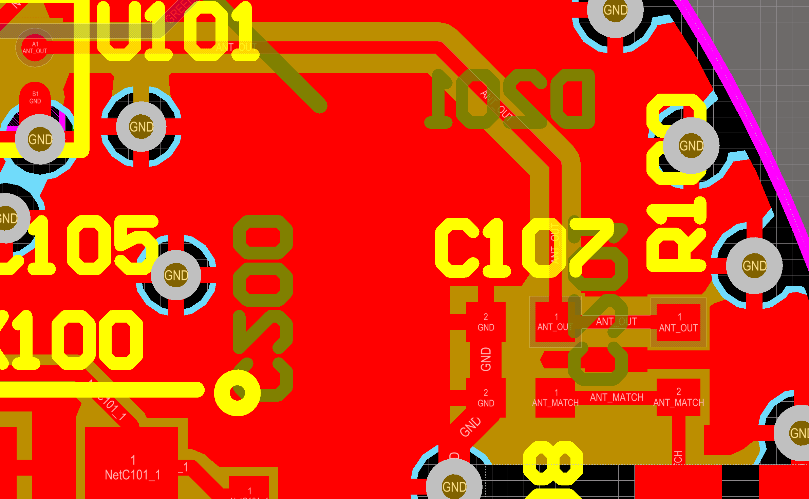

Fig. 2: Single 50ohm traces